Cairo University Faculty of Computers and Information



**CS352 – Software Engineering II**

**Software design specification document**

**2018**

**Project Team**

|  |  |
| --- | --- |
| **ID** | **Name** |
| **20150033** | **Ahmed Mohammed Galal** |
| **20150244** | **Mahmoud Mossad Mohammed** |
| **20130238** | **Mariam Abd El-Naby Ahmed** |
| **20140359** | **Batool Eyad Omar** |

**[TA. Omar Khaled]**

Contents

Class diagram design 2

Sequence diagram design 3

Github repository link 3

# Class diagram design

First Class Diagram:

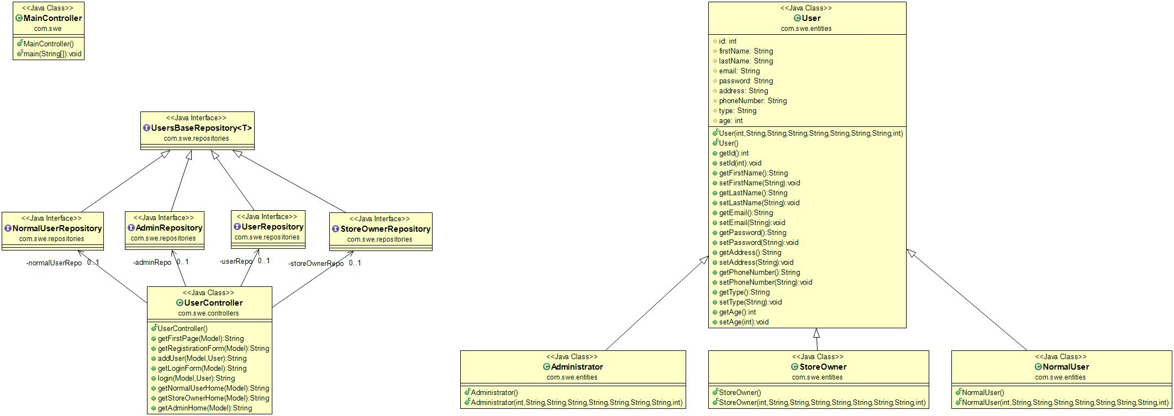

Another Class Diagram:

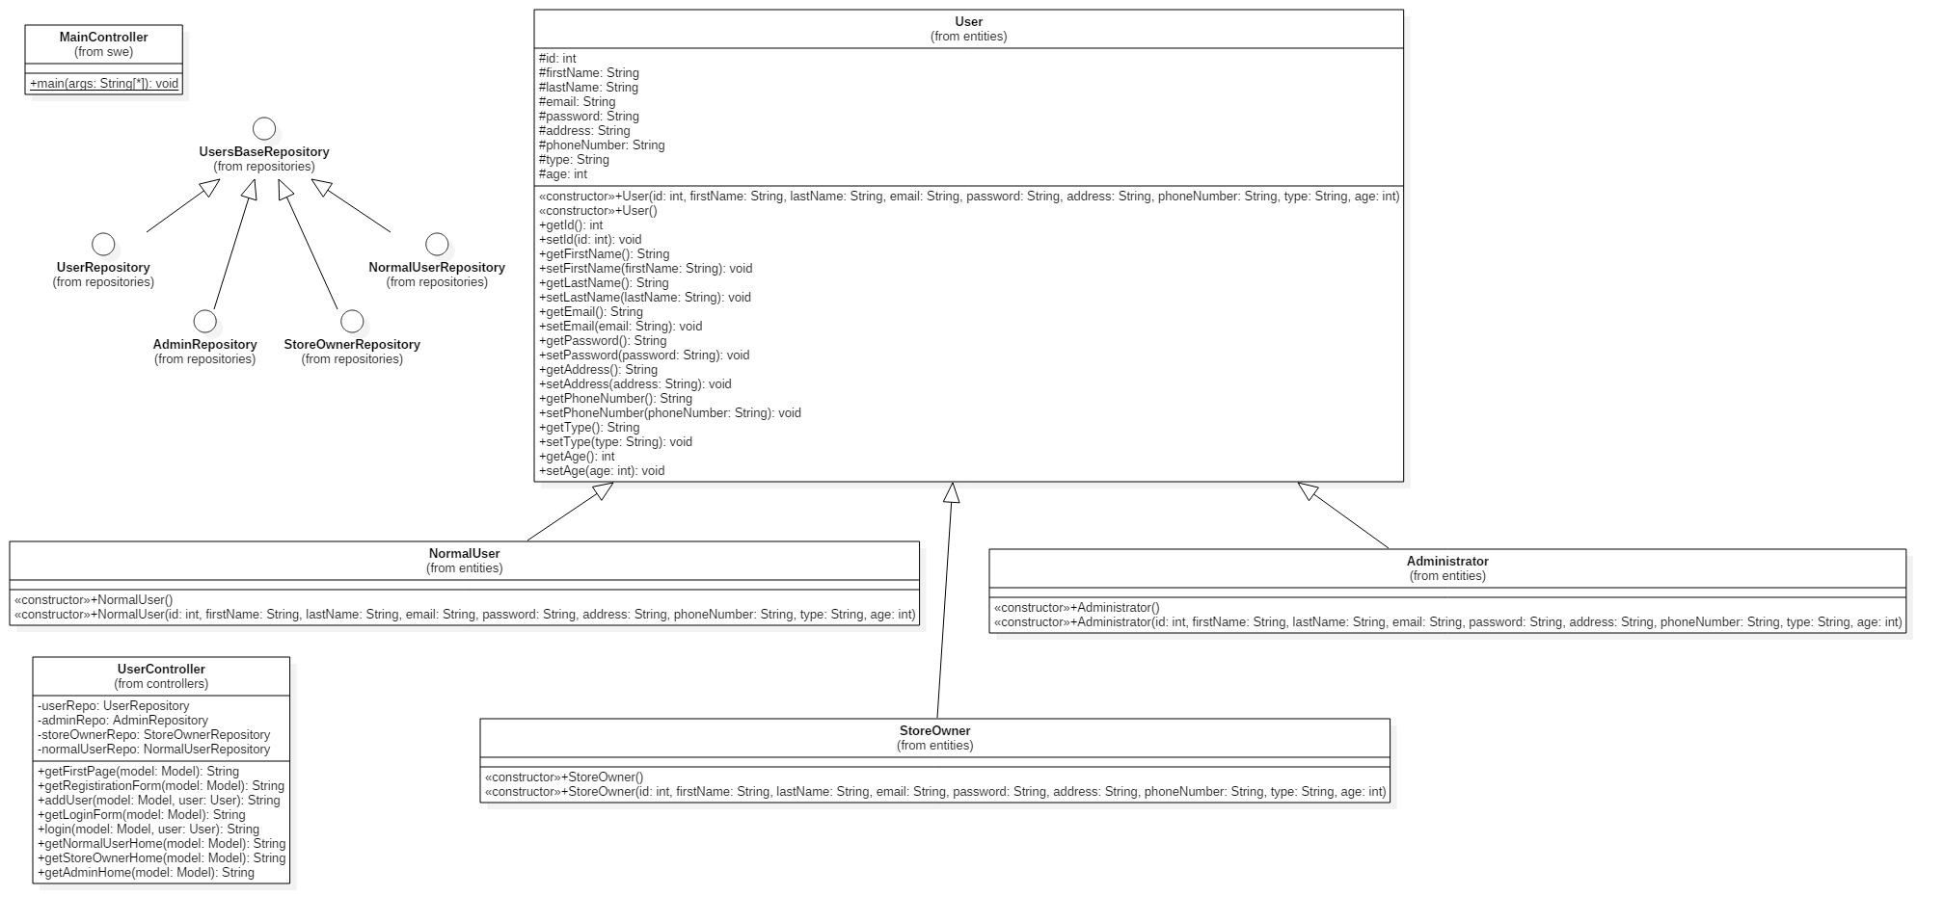

# Sequence diagram design

# 

# Github repository link

* ***https://github.com/DynamOo/OnlineStoreProject***